**EXPERIMENT 4**

**Aim :**

To prepare Use Case Diagrams for the Application Software – **Bill Management System.**

**Theory :**

**What is a Use Case Diagram ?**

In the Unified Modelling Language (UML), a use case diagram can summarize the details of your system's users (also known as actors) and their interactions with the system. To build one, you'll use a set of specialized symbols and connectors. An effective use case diagram can help your team discuss and represent :

* Scenarios in which your system or application interacts with people, organizations, or external systems
* Goals that your system or application helps those entities (known as actors) achieve
* The scope of your system

**When to apply Use Case Diagrams ?**

A use case diagram doesn't go into a lot of detail. Instead, a proper use case diagram depicts a high-level overview of the relationship between use cases, actors, and systems. Use cases are represented with a labelled oval shape. Stick figures represent actors in the process, and the actor's participation in the system is modelled with a line between the actor and use case. To depict the system boundary, draw a box around the use case itself. Use case diagrams are ideal for :

* Representing the goals of system-user interactions
* Defining and organizing functional requirements in a system
* Specifying the context and requirements of a system
* Modelling the basic flow of events in a use case

**What are the Components of Use Case Diagram ?**

* **Actors :** The users that interact with a system. An actor can be a person, an organization, or an outside system that interacts with your application or system. They must be external objects that produce or consume data.
* **System :** A specific sequence of actions and interactions between actors and the system. A system may also be referred to as a scenario.
* **Goals :** The end result of most use cases. A successful diagram should describe the activities and variants used to reach the goal.

**Use Case Diagram Symbols and Notation :**

* **Use Cases :** Horizontally shaped ovals that represent the different uses that a user might have.
* **Actors :** Stick figures that represent the people actually employing the use cases.
* **Associations :** A line between actors and use cases. In complex diagrams, it is important to know which actors are associated with which use cases.
* **System Boundary Boxes :** A box that sets a system scope to use cases. All use cases outside the box would be considered outside the scope of that system.
* **Packages :** A UML shape that allows you to put different elements into groups. Just as with component diagrams, these groupings are represented as file folders.

Use Case Diagrams for the Application Software – **Bill Management System :**

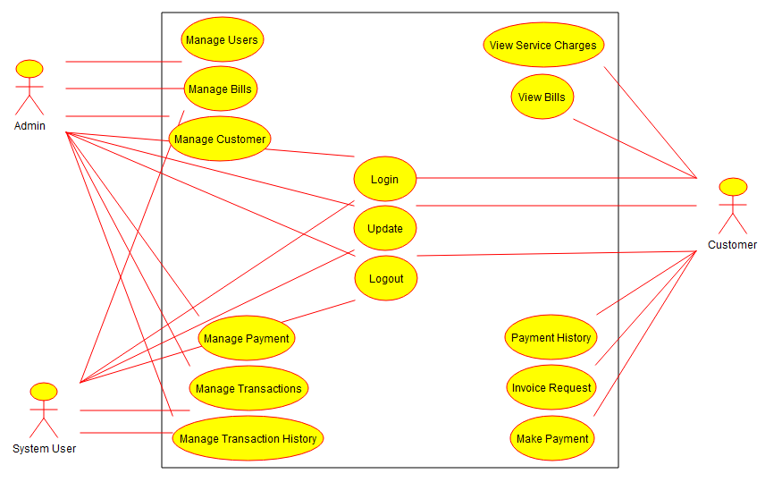

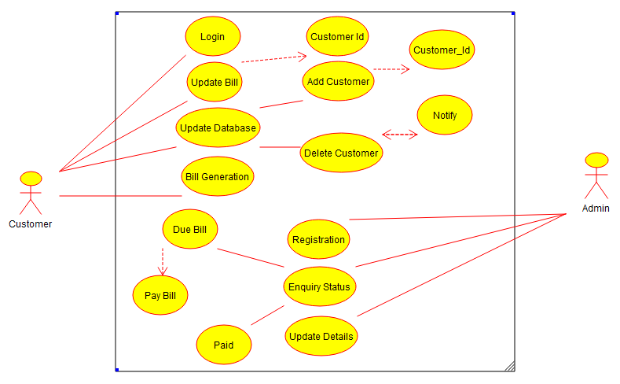

**Conclusion :** The Use Case Diagrams for the Application Software – **Bill Management System** were prepared successfully.